

**Institute of Technology of Cambodia**

**Department of Information Communication Engineering**

**Subject: Internet Programming**

**Lecturer: HOK TIN**

**TP7**

Name: Doeurn Sreynith

ID: e20190214

Group: GIC-A

**2022-2023**

GitHub: <https://github.com/Doeurn-Sreynith/Internet-Programming/tree/main/TP7>

Contents

Exercise1: 4

Exercise2: 5

Exercise3: 6

# Exercise1:

**OUTPUT:**

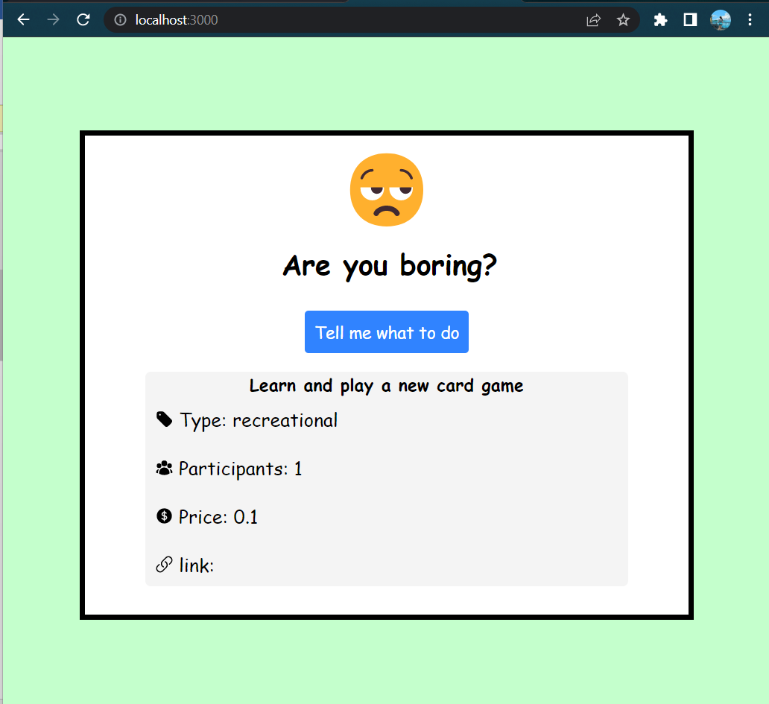

# Exercise2:

**OUTPUT:**

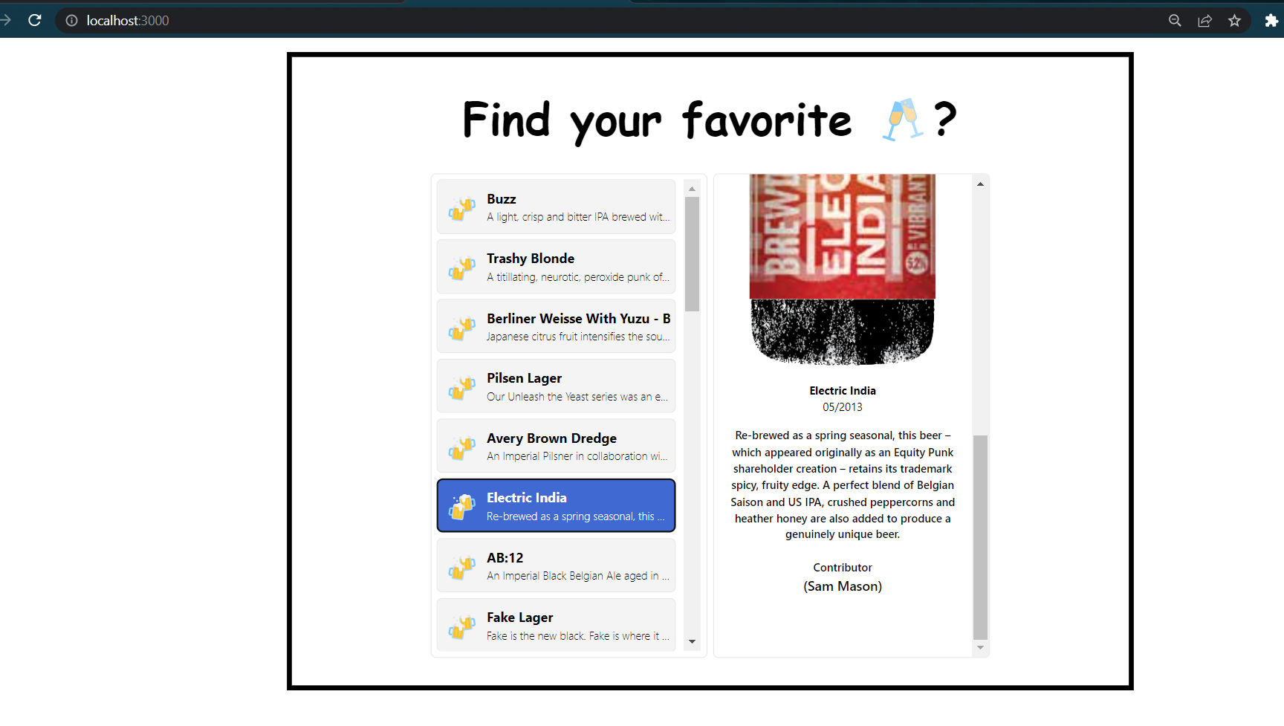

# Exercise3:

**OUTPUT:**

